

**X路**

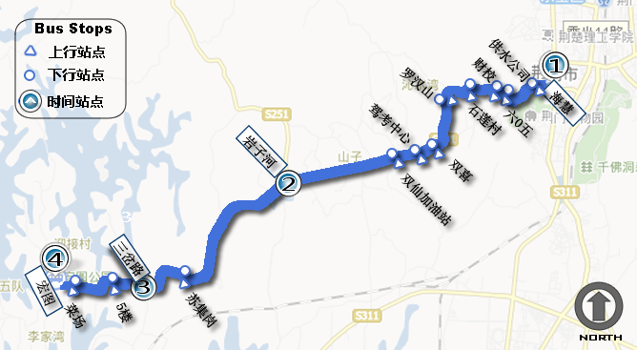

|  |  |  |  |  |  |  |  |  |  |  |
| --- | --- | --- | --- | --- | --- | --- | --- | --- | --- | --- |
| 11路Title.png | | | | | | | | | | |
| 上行：海惠-宏图 单程时间：0:33:26 | | | | | | **下行：宏图-海惠 单程时间：0:34:00** | | | | |
| 工 作 日 ( 周 一 至 周 五 ) |  |  |  |  |  | 5:30 | 5:37 | 5:42 | 5:56 | 6:09 |
|  |  |  |  |  | 5:35 | 5:42 | 5:47 | 6:01 | 6:14 |
|  |  |  |  |  | 5:40 | 5:47 | 5:52 | 6:06 | 6:19 |
|  |  |  |  |  | 5:45 | 5:52 | 5:57 | 6:11 | 6:24 |
|  |  |  |  |  | 5:50 | 5:57 | 6:02 | 6:16 | 6:29 |
|  |  |  |  |  | 5:55 | 6:02 | 6:07 | 6:21 | 6:34 |
| 6:00 | 6:09 | 6:15 | 6:31 | 6:45 | 6:00 | 6:07 | 6:12 | 6:26 | 6:39 |
|  |  |  |  |  |  |  |  |  |  |
|  |  |  |  |  |  |  |  |  |  |
|  |  |  |  |  |  |  |  |  |  |
|  |  |  |  |  |  |  |  |  |  |
|  |  |  |  |  |  |  |  |  |  |
|  |  |  |  |  |  |  |  |  |  |
|  |  |  |  |  |  |  |  |  |  |
|  |  |  |  |  |  |  |  |  |  |
|  |  |  |  |  |  |  |  |  |  |
|  |  |  |  |  |  |  |  |  |  |
|  |  |  |  |  |  |  |  |  |  |
|  |  |  |  |  |  |  |  |  |  |
|  |  |  |  |  |  |  |  |  |  |



**X路**

|  |  |  |  |  |  |  |  |  |  |  |
| --- | --- | --- | --- | --- | --- | --- | --- | --- | --- | --- |
| 11路Title.png | | | | | | | | | | |
| 上行：海惠-宏图 单程时间：0:34:41 | | | | | | **下行：宏图-海惠 单程时间：0:34:34** | | | | |
| 周 末 （ 周 六 和 周 日 ） | 5:30 | 5:37 | 5:42 | 5:56 | 6:09 |  |  |  |  |  |
| 5:35 | 5:42 | 5:47 | 6:01 | 6:14 |  |  |  |  |  |
| 5:40 | 5:47 | 5:52 | 6:06 | 6:19 |  |  |  |  |  |
| 5:45 | 5:52 | 5:57 | 6:11 | 6:24 |  |  |  |  |  |
| 5:50 | 5:57 | 6:02 | 6:16 | 6:29 |  |  |  |  |  |
| 5:55 | 6:02 | 6:07 | 6:21 | 6:34 |  |  |  |  |  |
|  |  |  |  |  |  |  |  |  |  |
|  |  |  |  |  |  |  |  |  |  |
|  |  |  |  |  |  |  |  |  |  |
|  |  |  |  |  |  |  |  |  |  |
|  |  |  |  |  |  |  |  |  |  |
|  |  |  |  |  |  |  |  |  |  |
|  |  |  |  |  |  |  |  |  |  |
|  |  |  |  |  |  |  |  |  |  |
|  |  |  |  |  |  |  |  |  |  |
|  |  |  |  |  |  |  |  |  |  |
|  |  |  |  |  |  |  |  |  |  |
|  |  |  |  |  |  |  |  |  |  |
|  |  |  |  |  |  |  |  |  |  |
|  |  |  |  |  |  |  |  |  |  |